dd01510_

pe03204_

Netherley Youth & Community Initiative

Damson road, Netherley,

Liverpool, L27 8XR

Tel/Fax: 0151 487 6421

Email:admin@nyci.co.uk

Reg. Charity No.1112225

Company’s No. 5531622

**NY&CI**

Playscheme -CHILD REGISTRATION FORM 2023/2024

NAME................................................................................DATE OF BIRTH......................................

Gender: …………….…………………..… Ethnicity …………………………..…………………..

ADDRESS..........................................................................................................................................

POSTCODE.................................

EMAIL..................................................................................

Do you receive Free school meals….Yes/No

**Emergency Contact Details 1**

Name........................................................................Relationship to child.........................................

Address…………………….................................................................................................................

Contact Number.................................................................................................................................

**Emergency Contact Details 2**

Name.................................................................... Relationship to child............................................

Address.............................................................................................................................................

Contact Number................................................................................................................................

**To ensure that NY&CI can contact a responsible person in case of need**

School attended.................................................................................................................................

Doctors Name and address..............................................................................................................................................

**Does your child have any health issues or disabilities (including allergies) please specify?**

|  |
| --- |
|  |

All the above information is correct to my knowledge

Signature of Legal responsible person.................................................................Date …..…..........

**Medical consent**

**I/We** hereby consent to any necessary medical treatment (which may include the use of anaesthetics) by a recognised qualified professional, providing that every effort has been made to contact me and failed, and if the delay is considered unadvisable by the medical professional concerned:

**I do / do not** give NY&CI full rights to use the images resulting from the photography/video filming, and any reproductions or adaptations of the images for fundraising, publicity or other purposes to help achieve the Club’s aims. This might include (but is not limited to), the right to use them in their printed and online publicity, social media, press releases and funding applications

**I do / I do not** give permission for my son/daughter to have calpol

**I do / I do not** give permission for my son/daughter to have suncream applied

LCC Data Form completed Yes / No

**Signed by Legal Responsible person............................................................................................**

Does your child have any religious or dietary restrictions/requirements? Please include any food allergies so we can be sure to offer your child an alternative.

|  |
| --- |
|  |

Any further information that you feel will help us to ensure your child’s wellbeing, additional support needs. Please specify

|  |
| --- |
|  |

 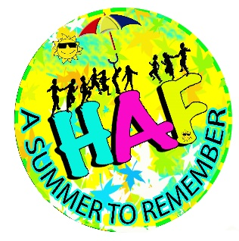 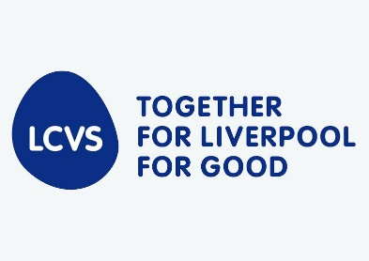

**To reduce paper-waste this form covers July 2021-August 2022 – Please sign and date to confirm information is still valid.**

|  |  |  |
| --- | --- | --- |
|  |  |  |
|  |  |  |
|  |  |  |
|  |  |  |
|  |  |  |
|  |  |  |